Resolving Merge Conflict

- Verify if master is in clean state
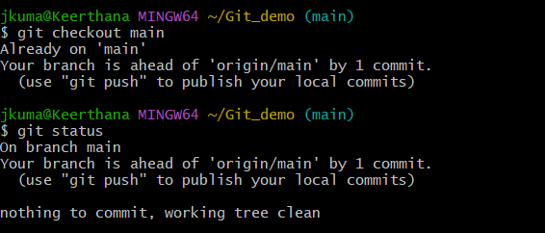

- Create branch GitWork and add hello.xml
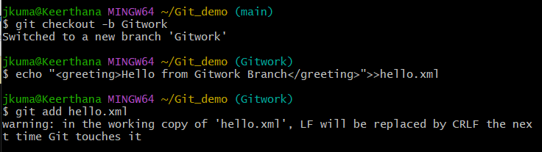

- Update content of hello.xml and observe status
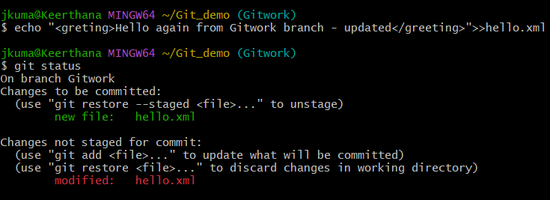

- Commit changes to branch
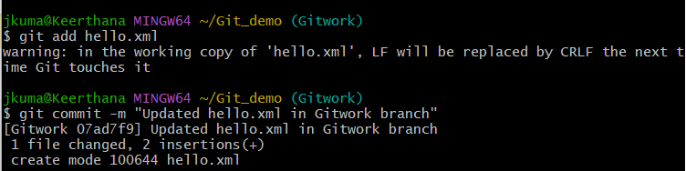

- Switch to main


- Add hello.xml in main with different content
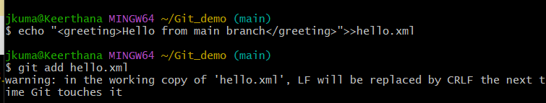

- Commit changes to main


- Observe log
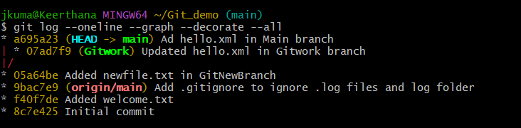

- Check differences with gitdiff tool
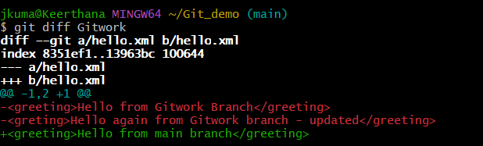

- Use P4Merge for better visualization


- Merge branch into master


- Observe the git mark-up
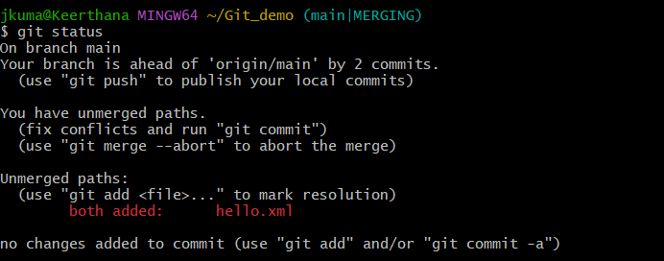

- Use 3-way merge tool to resolve conflict
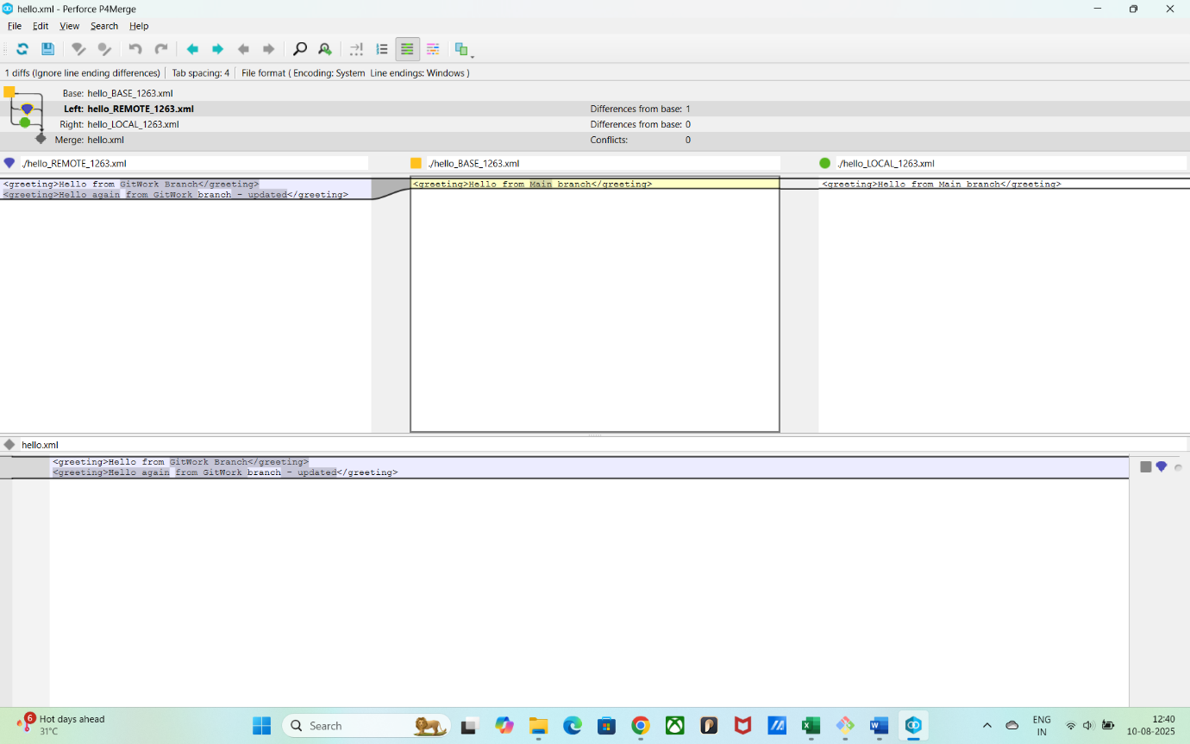
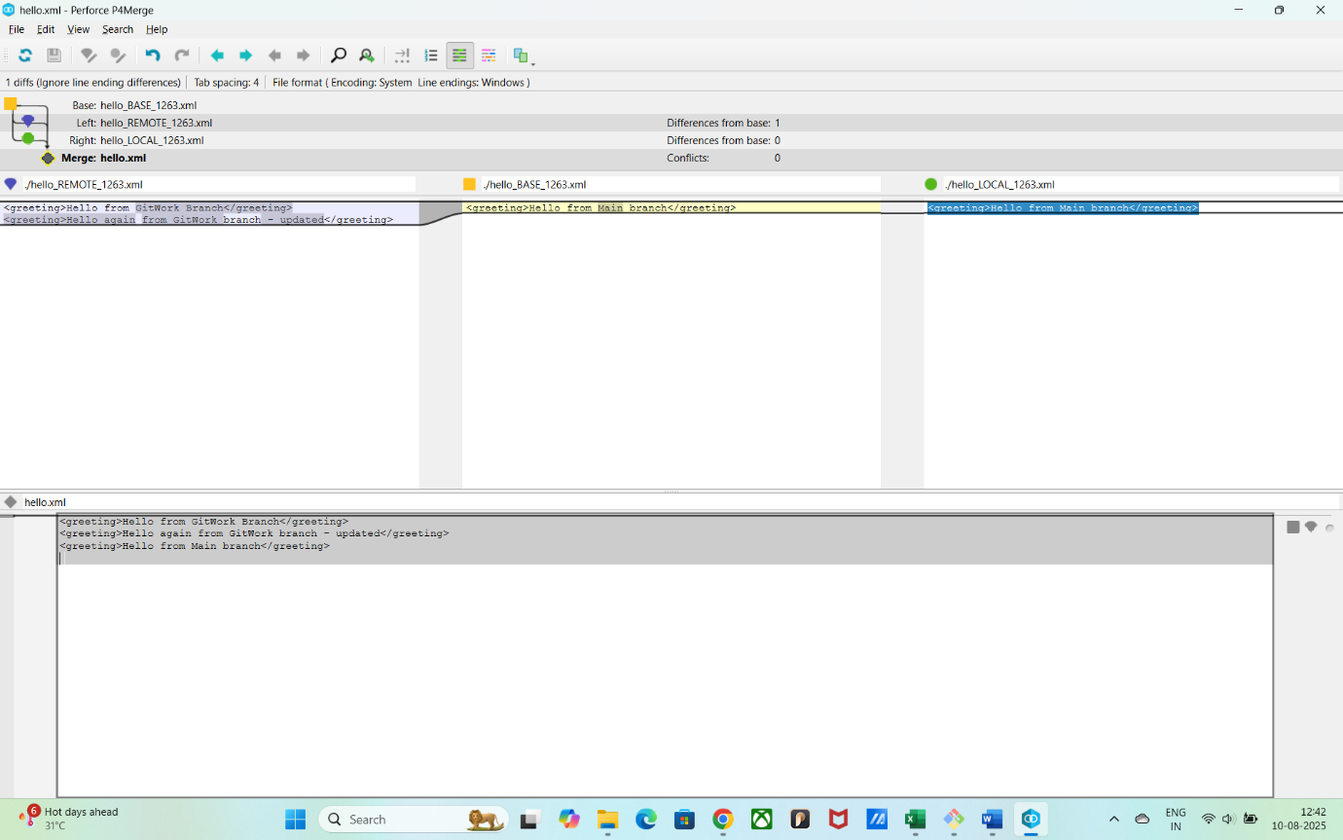

- Commit after conflict resolution

- Observe git status & add backup file to .gitignore

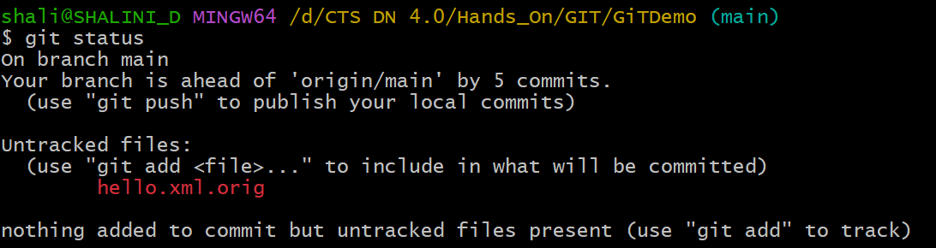

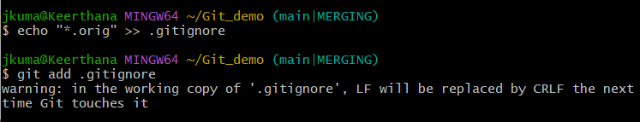

- List all available branches

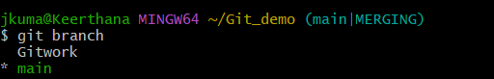

- Delete merged branch

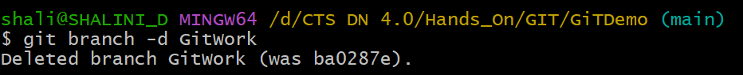

- Observe final log

